**SUPERIOR UNIVERSITY LAHORE**



**Faculty of Computer Science & IT**

**Semester Final Project**

**Web Application and Development**

**Student Details**

|  |  |  |
| --- | --- | --- |
| **Student Name** | **Roll #** | **Class** |
| Zeeshan Siddique | BCSM‐S18‐012 | BSCS-4A |

**Submitted To:**

**Mr. Umair**

**Project Title:** **Panda**

**Introduction:**

In my project “Panda” this is a website where people can buy clothes and many things according to latest fashion either for girls or boys. Everyone can easily purchase clothes and many other useful things through my website. This website is very friendly-user. This website is categorized in an easy way to understand the collections.

Customer can search easily any new arrivals such as: clothes collection, waistcoats, footwear, shawls, perfumes, bags, makeover related things etc. Customer can easily buy online by placing an order according to size, design and prices. For this method, customer can create an account and login in my site for placing an order online to purchase something.Customer can send an email to ask any type of query about arrivals of new collections. My website is activate 24/7 hours. I’ll give reply at right time according to their questions.The website serves as a platform for users to ask any query through membership and active participation. Customer can follow us through their Facebook , Twitter and YouTube accounts as well.

**Languages:**

* **HTML**
* **CSS**
* **JSX**
* **BOOTSTRAP**

**Components:**

* **Header**
* **FirstPage**
* **Mainbody**
* **New Arrivals**
* **Men**
* **Women**
* **Boys & Girls**
* **Makeup**
* **Fragrances**
* **Catalog**
* **Login**
* **Contact Us**
* **Footer**

**First Page to Select Country:**

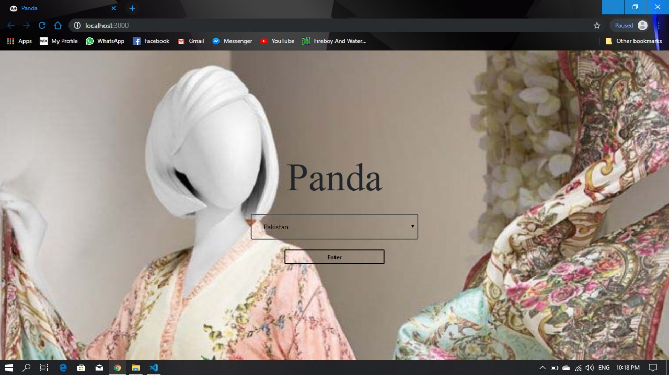

## **Home Page *(With Mouse Over Categories)***

This is my front page where people will see all collections by selecting any category of their choice. Clothes are categorized in very manageable way such as: unstitched or stitched collection.

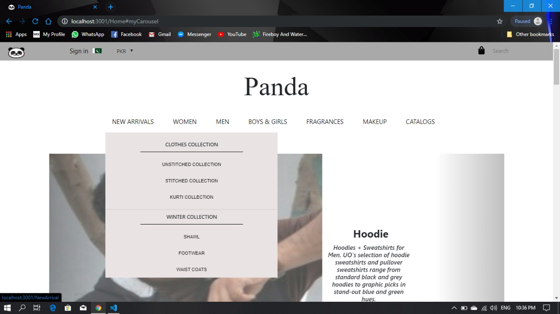

**Collections*(With Text on Pictures)***

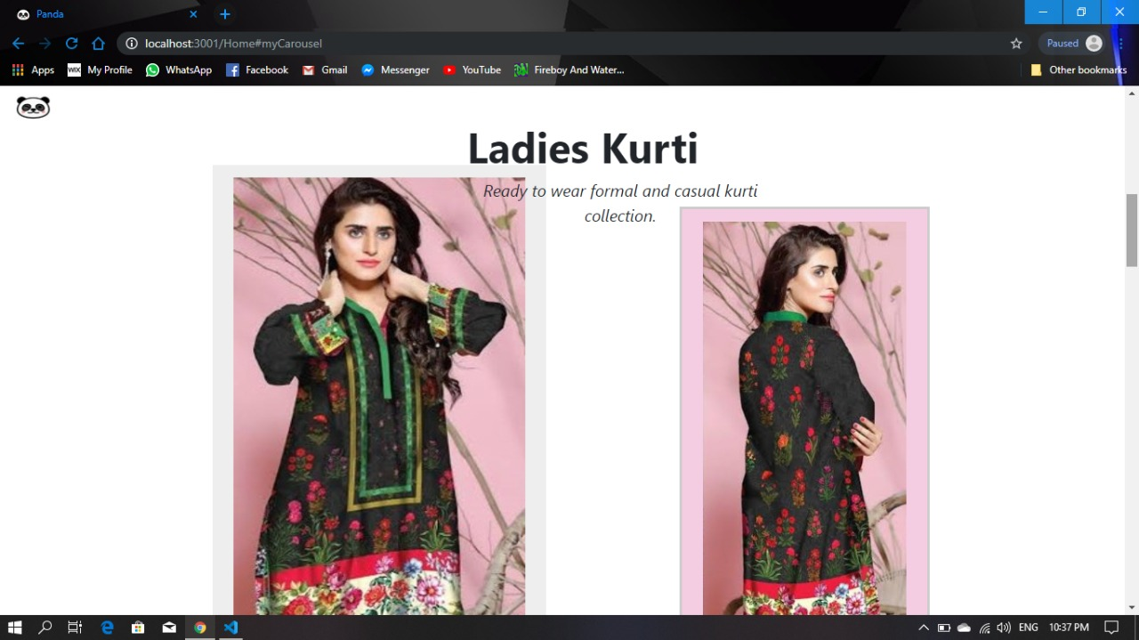

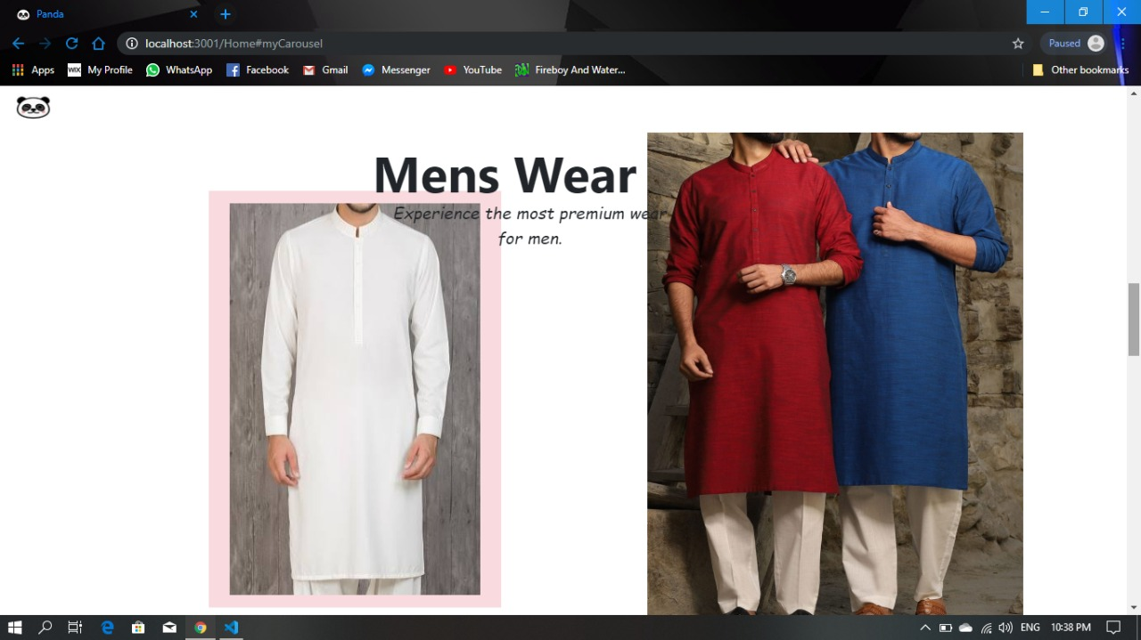

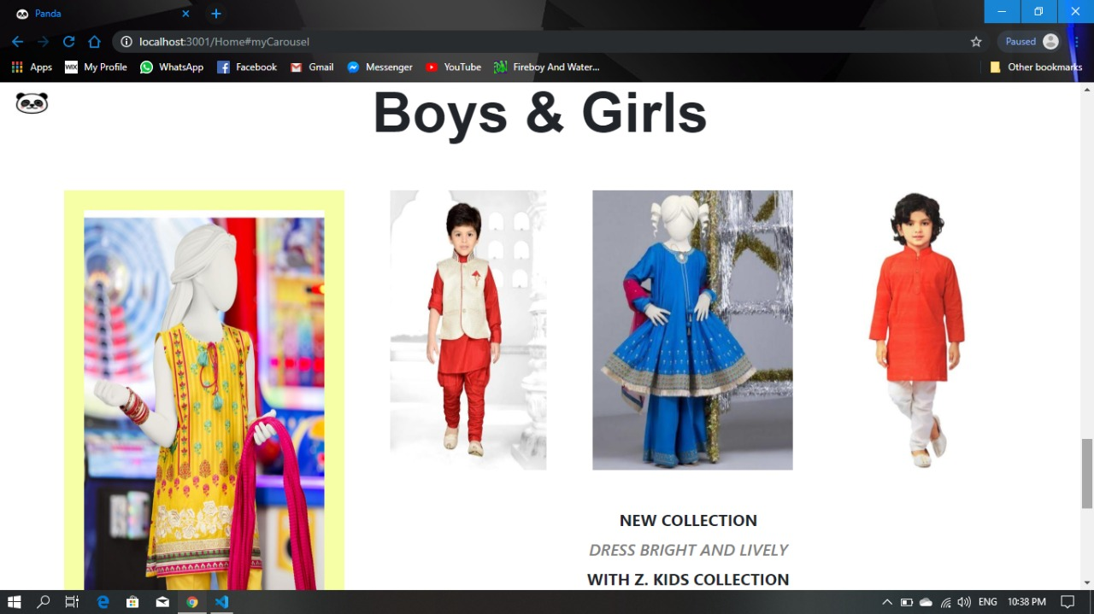

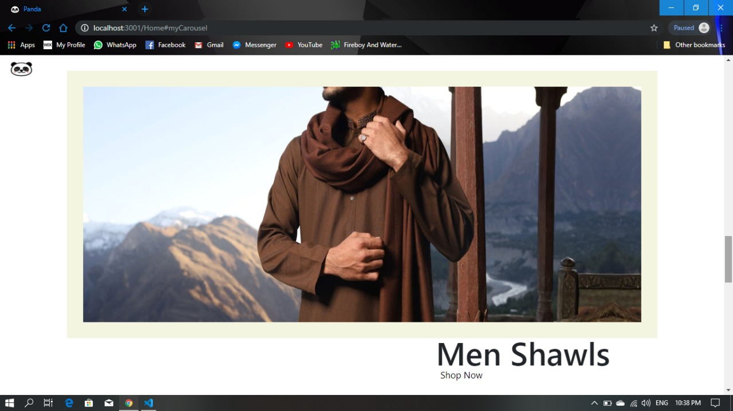

**Categories*(With Filter Option)***

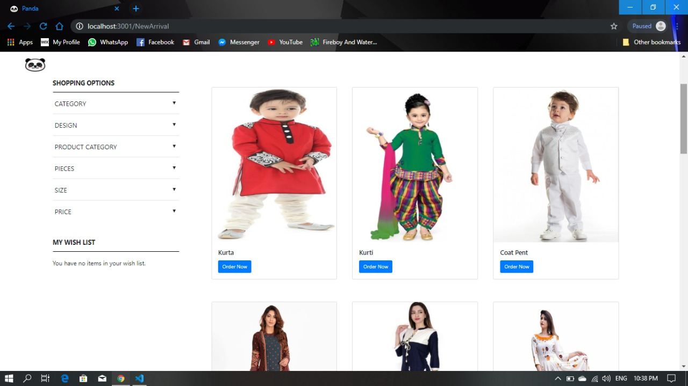

**Information Page**

Customer can get more information about the site by visiting the about section.

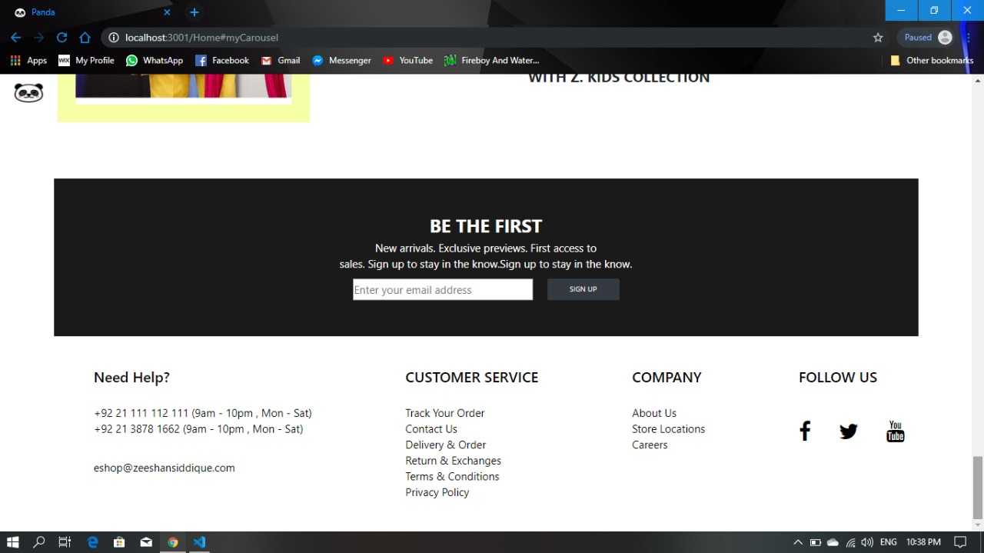

**Login Page/SignUp Page**

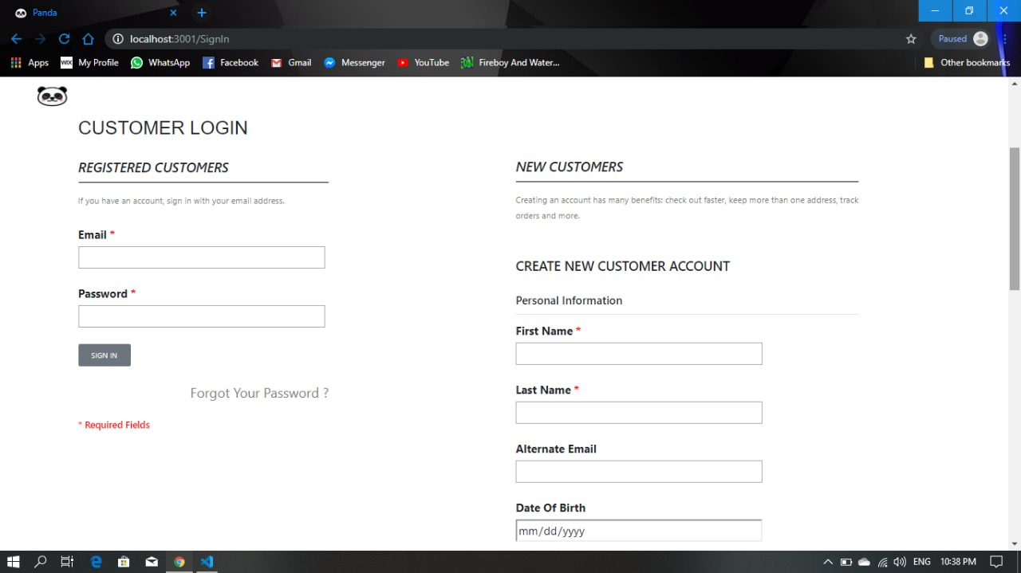To get registered, user have to visit this page.

**For Queries**

This section will allow you to get in touch for any kind of query or information.

